**CURRICULUM VITAE**

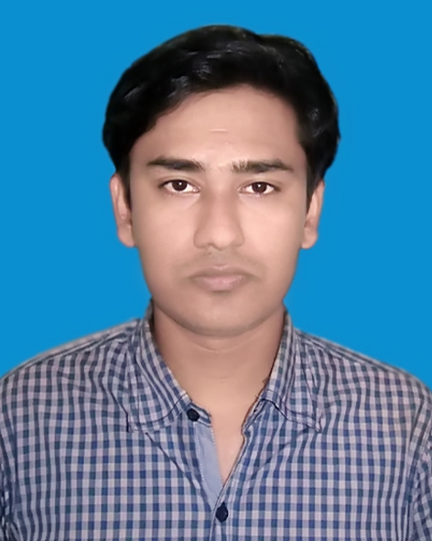

of

**Md. Mosharaf Hossain**

C/O. Sabid Miar Chairman Puraton Bari

Village: Harinarayanpur, P.O: Maijdee

P.S: Sadar, Dist: Noakhali

Mobile: 01843449953

Email: mdmhazim@gmail.com

**Objective** : To build up a respectable career in a reputed institute where I can be able to prove my competence.

**Education** **B. B. S (Honours)**

University : National University

Subject : Accounting

Year : 2011

Result : First Class

**Higher Secondary Certificate(H.S.C)**

Board : Comilla Board

Group : Business Studies

Year : 2007

Result : 3.60

**Secondary School Certificate(S.S.C)**

Board : Comilla Board

Group : Business Studies

Year : 2005

Result : 4.00

**Computer** :I have successfully completed Training course in MS office EXPERT program of six months duration and duly passed the final examination from FPAB

Institute,Noakhali.

**Language** : Bengali : Excellent

**Proficiency** : English : Good

**Hobbies** :Reading books,Internet browsing and Travelling.

**Personal Details:**

Father’s Name : Md. Abul Kalam

Mother’s Name : Rokeya Begum

Permanent Address : C/O. Sabid Miar Chairman Puraton Bari

Village: Harinarayanpur, P.O: Maijdee

P.S: Sadar, Dist: Noakhali

Date of Birth :1st November 1989

Nationality : Bangladeshi (by birth)

Religion : Islam

Marital Status :Single

NID : 7528705131834

Home District : Noakhali

**REFERENCE:**

**Md. Delwar Hossain**

Associate Professor

Dept. of Accounting

Chowmuhani Govt. S.A College.

Noakhali

Contact No: 01813122118

**Declaration of Authenticity**

|  |
| --- |
| I do hereby declare that all information have presented are true to my knowledge, If required and where applicable, this document can be supported by appropriate authentic certificates or papers. |

----------------------------------------------

(Md. Mosharaf Hossain)